Distributed Databases
Suppose that EMP table is distributed into 4 fragments (department wise). The fragment names are F10, F20, F30, and F40. The distributed database is deployed at 5 sites, and every site contains its local fragment plus other fragments.
- Create the following table "Distributed", and insert the following data to maintain fragments-sites mapping:

Site | Fragment1 | Fragment2 | Fragment3 | Load | Counter
S1020 | F10 | F20 | NULL | Low | 0
S1030 | F10 | F30 | NULL | Medium | 5
S3040 | F30 | F40 | NULL | Low | 0
S203040 | F20 | F30 | F40 | High | 10
S2040 | F20 | F40 | NULL | Medium | 5

CREATE TABLE DISTRIBUTED
(
SITE VARCHAR2(10) PRIMARY KEY,
FRAGMENT1 VARCHAR2(10) NOT NULL,
FRAGMENT2 VARCHAR2(10) NOT NULL,
FRAGMENT3 VARCHAR2(10),
LOAD VARCHAR2(10),
COUNTER NUMBER
);

INSERT INTO DISTRIBUTED(SITE,FRAGMENT1,FRAGMENT2,FRAGMENT3,LOAD,COUNTER)
VALUES ('S1020','F10','F20',NULL,'LOW',0);
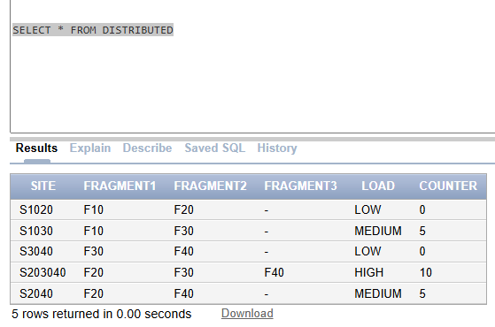

- Create a PL/SQL procedure process_query(site VARCHAR2, fragments VARCHAR2). The parameter fragments contains the fragment(s) referred in the query, such as F10, (F10,F20), (F30,F40) etc. The default value of fragments is F10,F20,F30,F40. The parameter site refers the query site.

The procedure will make the query execution plan as per the following options:

  - The query must use all the local fragments (if referred).
  - Involve minimum sites for query execution.
  - If a fragment referred in the query is available at multiple sites, then select a site with lesser load.

In the end, the procedure will increment the Counter of all the sites used for query execution.
CREATE OR REPLACE PROCEDURE process_query(P_site VARCHAR2, fragments VARCHAR2 DEFAULT 'F10,F20,F30,F40') IS
LOCAL_FRAGMENT VARCHAR2(100);
MIN_SITE VARCHAR2(10);
MIN_LOAD NUMBER;
SELECT fragment1,fragment2,fragment3 into local_fragment
FROM distributed
WHERE site = P_site;
BEGIN
FOR fragment_rec IN fragment_cursor LOOP
DBMS_OUTPUT.PUT_LINE('Local fragment: ' || fragment_rec.fragment);
END LOOP;
UPDATE distributed
SET counter = counter + 1
WHERE site = MIN_SITE;
END;

- Create a PL/SQL trigger post_update_distributed that will fire after the update of Counter of a certain row. The trigger should update the Load from Low to Medium when the Counter value hits 5. Similarly, the trigger should update the Load from Medium to High when the Counter value hits 10.
Sample Execution
Procedure Call | Procedure Output (Actions)
 | Site | Fragment | Counter | Load
convert_query(10); | S1020 | F10 | 1 | Low
convert_query(10,40); | S1020 | F10 | 2 | Low
 | S3040 | F40 | 1 | Low
convert_query; | S1020 | F10, F20 | 3 | Low
 | S3040 | F30, F40 | 2 | Low

CREATE OR REPLACE TRIGGER post_update_distributed
AFTER UPDATE OF COUNTER ON DISTRIBUTED
FOR EACH ROW
BEGIN
IF :NEW.COUNTER >= 5 THEN
UPDATE DISTRIBUTED
SET LOAD = 'MEDIUM'
WHERE SITE = :NEW.SITE;
ELSIF :NEW.COUNTER >=10 THEN
UPDATE DISTRIBUTED
SET LOAD = 'HIGH'
WHERE SITE = :NEW.SITE;
END IF;
END;

UPDATE DISTRIBUTED SET COUNTER = 6 WHERE SITE = 'S1020';

